
这是我的卧室。
zhè shì Wǒ de wòshì。

www.toondoo.com
1. Log in and search for the items you need or you want 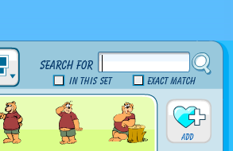
- MISSION 1: create your own 卧室wòshì
  - Some furniture must be in 你的卧室，they are:
  - 床chuáng bed
  - 桌子zhuōzi table
  - 椅子yǐzi chair
YOU SHOULD HAVE FINISHED.
  - 柜子guìzi cupboard
  - 书架shūjià bookshelf
  - 灯dēng lamp
  - 门mén door
  - 电脑diànnǎo computer
2. Go to My ToonDoos 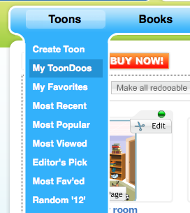 and click your picture.
Save this ToonDoo to your computer. 

3. Open Word Office, and insert your ToonDoo.
4. Write at least 5 sentences about你的卧室.
- MISSION 2: create your own 卧室wòshì article
  - Some sentence patterns must be in the writing, they are:
  - 我的卧室里有…。
  - 床（桌子，椅子…）上／下有…。
  - Remember the measure words: 张，个，把，本
5. Print it and hand it in before break time.

