
这是我的卧室。
zhè shì Wǒ de wòshì。

www.toondoo.com
1. Log in - Create Toon 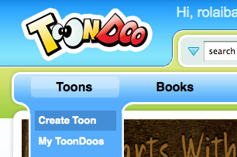 -
2. Horizontal Layout(one square) 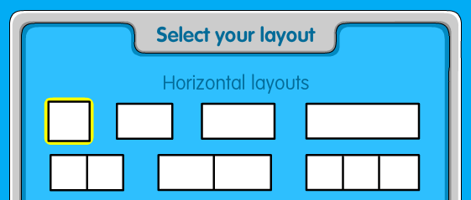
3. Search for the items you need or you want 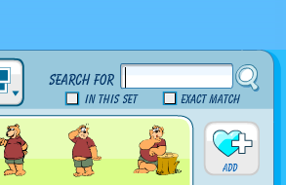
- Mission: create your own 卧室wòshì
  - Some furniture must be in 你的卧室，they are:
  - 床chuáng bed
  - 桌子zhuōzi table
  - 椅子yǐzi chair
  - 柜子guìzi cupboard
  - 书架shūjià bookshelf
  - 灯dēng lamp
  - 门mén door
  - 电脑diànnǎo computer

4. Save your file 