 | 二年级  进步2_单元2  测验（一）

姓名:______________________
A、听力测验Listening
一、选出正确的答案
Match what you hear to the correct picture/translation.

1. ( ) a. b.  c.  d. 
2. ( ) a.  b. 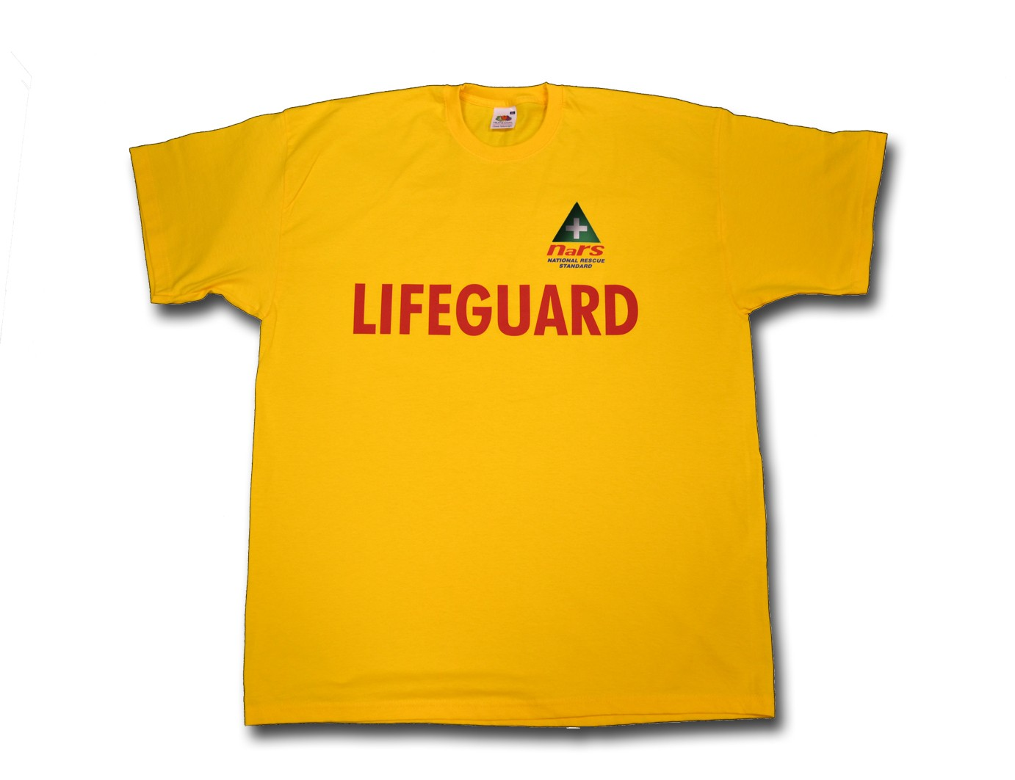 c. 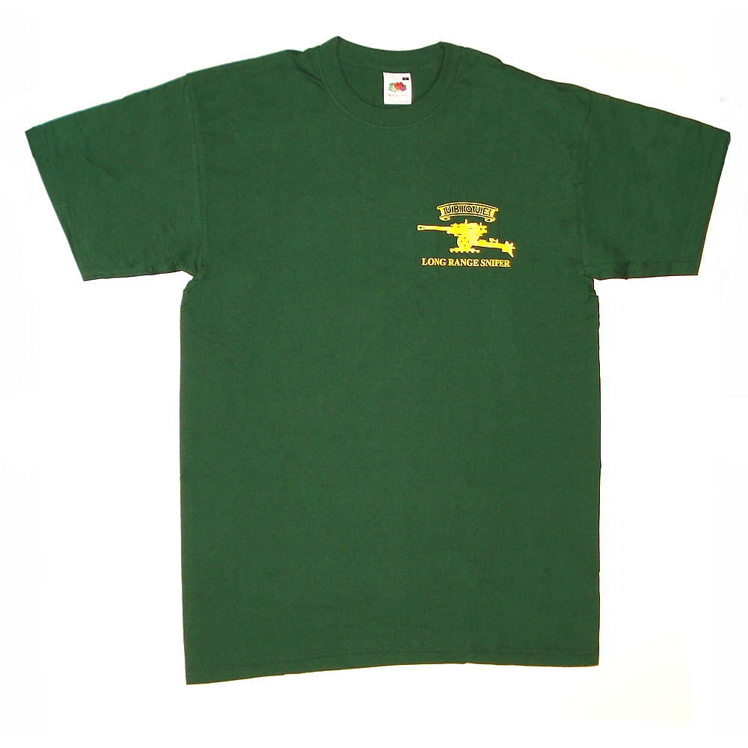 d. 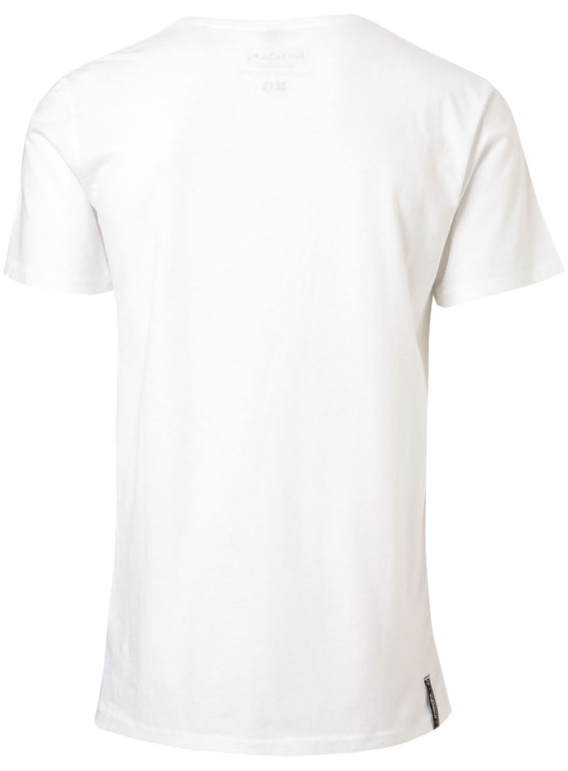

3. ( ) a. tall and fat b. short and fat c. tall and slim d. short and slim

4. ( ) a. long and black hair b. short and black hair
c. long and brown hair d. short and brown hair

5. ( ) a. 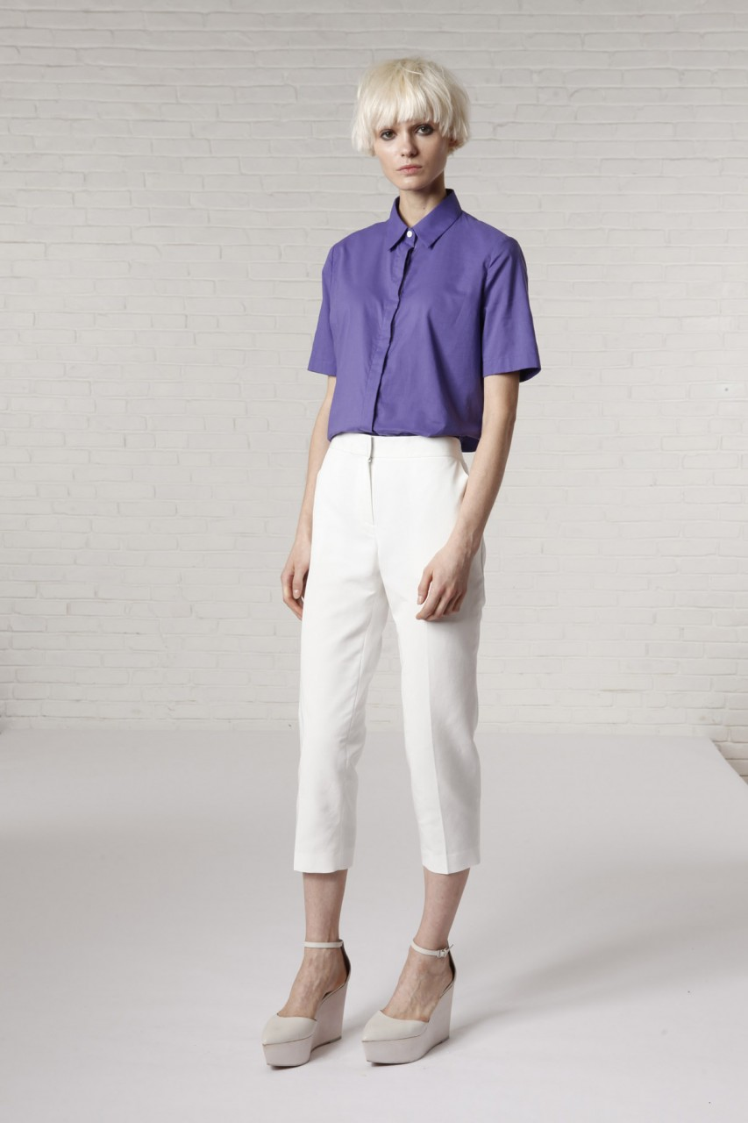 b.  c. 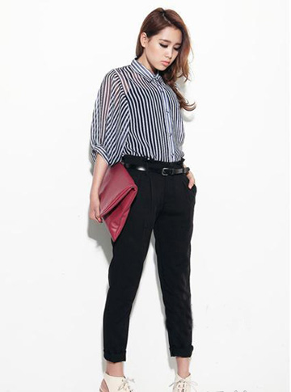 d. 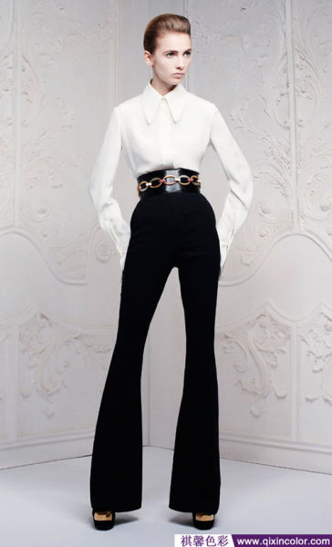

二、回答问题 Listen carefully and answer the questions.
1. 对或错True or False
Write ‘T’ for ‘True’ and ‘F’ for ‘False’ in the space provided.

1)_____ 阿波(A-Po) is 17 years old and he lives in China.

2)_____ 阿波(A-Po) can speak both Chinese and English.
2. 写出正确答案Write the correct answers
1）What does阿波(A-Po) say about his appearances? Mention any 2.

_____________________________________________________

2) What does 阿波(A-Po) like to wear? Mention any 1thing.

_____________________________________________________

* * * * *

B、阅读测验Reading
一、连连看Match the sentences and pictures.



.
.

我有长长的腿。

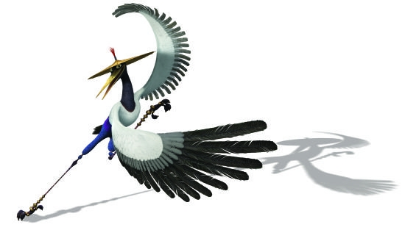
我穿红色的上衣，也有大大的牙齿。
.
.

我有又大又圆的耳朵。我很矮。
.

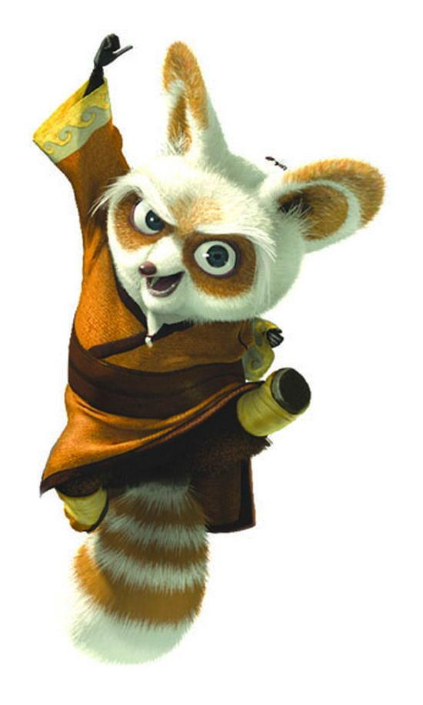

.

.
我戴一顶帽子。

二、回答问题 Read the short description about小美 Xiao Mei and 大中Da Zhong, then answer the questions.
小美*住在爱丁堡，今年十二岁，她长得很漂亮，也很高。她有一个中国朋友，他的名字叫大中*，他非常瘦。他们都喜欢听音乐和看书。

*小美 Xiao Mei, name of a Chinese person
*大中 Da Zhing, name of a Chinese person

1. 对或错True or False
Write ‘T’ for ‘True’ and ‘F’ for ‘False’ in the space provided.

1)_____ 小美is tall and thin.

2)_____ Both 小美and 大中 like listening to music and reading.

昨天，小美*和大中*早上九点起床，一起去买东西。小美买了一条黑色的裙子和两件白色的T恤衫；大中买了一双绿色的运动鞋和三条短裤。中午十二点，他们在中国餐厅*吃午饭。下午三点半，他们去电影院看电影。他们晚上六点回家。

*小美 Xiao Mei, name of a Chinese person
*大中 Da Zhing, name of a Chinese person
*中国餐厅Zhōngguó canting: Chinese restaurant
2. 写出正确答案Write the correct answers
1）What did 小美 and 大中buy? Mention any 2.

__________________________________________________________
2) When did they go to the movie?

__________________________________________________________
3) What did they do at 6pm?

