The Chinese calendar is made up of a cycle of years. | What does 年 mean？(2 answers)  - a year  - the name of a monster  - a dynasty of China | Why does the date for Chinese new Year changes?  a) it depends on when 星期天 is  b) it depends on the 天气  c) it depends on the new 月 appears
 | Chinese new year is also known as  - 春节Spring festival  - 冬至 Winter festival  - 夏至 Summer festival | Why do Chinese people let off firecrackers for Chinese New Year?  - to attract people’s attention  - to make huge noises to scare 年away  - to do it for fun
Which of the following is an animal in the Chinese zodiac？  a) 狗 b) 熊猫 c) 猫 | Wordsearch:  新年刮风下午熊猫兔子  节大国苏格兰上衣红包  音乐天气鱼鸡十天快乐  马中国喜欢好爱十二龙  中国熊猫喜欢红包新年快乐 | According to Chinese legend, which color has the ability to drive away bad luck and evil spirits?  a) 黄色 b) 蓝色 c) 红色
MATCH UP
Chinese Table Manners

1. Never Point the Chopsticks at Another Person-This is an Insult-
Respecting Seniors…

2. Wait for the Oldest Person at the Table to Start Before You Make Your Move

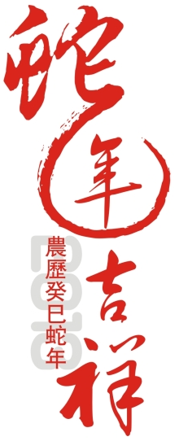

十二生肖xiāo

