你几点起床？
Ask your classmates, what time do they wake up? What time do they eat breakfast? ......
Write their names on the big clock.

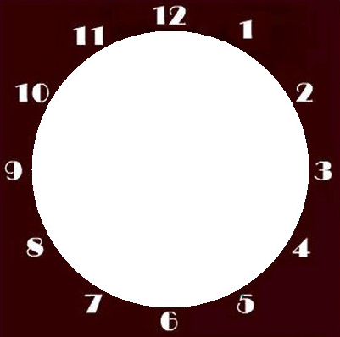
起床
整理书包
吃晚饭
洗澡
运动
做作业
吃午饭
上课
睡觉
上学
放学
回家

